
Request for Qualifications for Development Partner to Redevelop Tower Three

Issue Date January 7, 2026
Questions Related to RFQ due January 16, 2026
Pre-submission Meeting January 20
Submissions Due February 2, 2026

Table of Contents

SECTION I: REQUEST FOR QUALIFICATIONS SCHEDULE 3
SECTION II: PURPOSE OF RFQ AND BACKGROUND OF THE PROJECT AND ORGANIZATION 4
SECTION III: SCOPE OF SERVICES 7
SECTION IV: PROPERTY AND AREA INFORMATION 8
SECTION V: SENIOR CARE MODEL 11
SECTION VI: ZONING ANALYSIS 12
SECTION VII: PREDEVELOPMENT TEAM 14
SECTION VIII: PROPOSAL SUBMISSION REQUIREMENTS 15
SECTION XI: METHODOLOGY FOR EVALUATING QUALIFICATIONS 16

SECTION I: REQUEST FOR QUALIFICATIONS SCHEDULE
A: REQUEST FOR QUALIFICATIONS
The New Haven Jewish Community Council Housing Corporation, d/b/a The Towers at Tower Lane or ‘The Towers,’ has issued this Request for Qualifications (RFQ) to identify and qualify development partners to collaborate on the redevelopment of surplus property currently owned by The Towers and often referred to as “Tower Three”.
This Request for Qualifications (the “RFQ”) is available on or after Wednesday January 7, 2026.
B. CONTACT
The Towers sole contact for this RFQ is the following. All inquiries, correspondence, and submittals with respect to this RFQ must be sent in writing to the individual listed below:
Liz Torres
liztorres@housingsmarts.com
C. SUBMISSION DEADLINE
All RFQ responses (“Qualifications”) are due on February 2 by 5:00pm. The Towers reserves the right to reject responses received after this time. Respondents should submit their response by email in .pdf format. Qualifications will be received by the contact noted above.
D. SCHEDULE
RFQ Issue Date: Wednesday, January 7, 2026
(Optional) Questions Deadline: Friday, January 16, 2026
- Respondents have the opportunity to ask questions of the contact identified above. All inquiries, correspondence, and submittals with respect to this RFQ must be sent in writing. Questions following this date will not be answered to ensure equal opportunity among participants.
Pre-submission meeting: Tuesday, January 27, 2026 at 9:00 a.m.
RFQ Submission Deadline: Monday, February 2, 2026 at 5:00 p.m.
Select up to Three Respondents: Friday, February 20, 2026
Interview Respondents: Friday, March 6, 2026
Request for Proposals Due: Thursday, April 2, 2026

SECTION II: PURPOSE OF RFQ AND BACKGROUND OF THE PROJECT AND ORGANIZATION
PURPOSE
The New Haven Jewish Community Council Housing Corporation, d/b/a The Towers at Tower Lane or ‘The Towers,’ has issued this Request for Qualifications (RFQ) to identify firms interested in being considered to become The Towers’ development partner for the redevelopment of surplus land within The Towers campus. The new building to be built on the parcel is often referred to as “Tower Three.” Ultimately, it would be the intent of The Towers to narrow down the list of interested firms, meet with a selected few then issue a Request for Proposal (RFP) to those few firms (after signing confidentiality agreements). Based on the proposals received, The Towers intends to negotiate with the party chosen to be the co-developer for “Tower Three.”
THE TOWERS BACKROUND AND CONTEXT
Since the 1960s the New Haven Jewish community informally worked together to support one another to live more fulfilling and supported lives. It was not long before it became evident that a more formal approach was needed to support the community, particularly those aging in the community. To meet the growing need, a small group of community members formed the New Haven Jewish Community Council Housing Corporation (dba Tower One). Tower One was the first high-rise mixed-income apartment building located at 18 Tower Lane in The Hill section of New Haven. Tower One was completed and opened in 1971. Soon thereafter the same group of dedicated individuals discovered that there was significantly more need for affordable housing in New Haven than Tower One could provide. This led to the development of a second tower, Tower East opening in 1982.
Services such as shared dining options, community facilities, gardens, a basketball and a tennis court, enclosed courtyards, culturally sensitive enrichment programs and various other support services were integrated into The Towers’ buildings as our resident population continued to age and become frailer. This led to an increasing need for personal care services to be available onsite. Licensed assisted living, non-medical and medical home care services were added through preferred provider agreements throughout the early and mid-1990s. Through the efforts of the team at that time, not only were our residents enabled to remain in their homes and age gracefully, but their work also led to a new approach for connecting care services within a low- and moderate-income setting. Observing this, the State of Connecticut’s Office of Policy and Management (OPM) chose to expand the model in the late 1990s creating the Assisted Living Demonstration Pilot project based on The Towers’ model.
During the 2000s and 2010s, 150 rental units within The Towers were renovated and enlarged to better able support services to be provided within the apartment units. In 2017 Tower One and Tower East were merged into one entity, and the dba was changed to The Towers at Tower Lane. In 2019, after a significant discussion, The Towers Board of Directors decided that it was time to explore the reimagining of The Towers and our campus. We reflected on what worked well, considered changes and upgrades, evaluated where gaps may be and created a plan to increase services and housing options for more people in the community. As a result, The Towers embarked on a plan to reimagine its campus.
In February 2023, The Towers started the renovation of its 35,000 sq. ft. of ground floor common areas and program spaces to increase resident-use space and allow multiple evidence-based wellness programs to run concurrently. This $10M+ special project was completed on August 2025.
The next phase of The Towers planning efforts will improve its residential units and enhance the energy efficiency of the existing buildings. This phase is currently in process.
The final phase of The Towers plan is the exploration of redeveloping surplus land on its campus and expanding its housing and service offerings. This is the purpose of the RFQ and the RFP to follow.
In the initial stage of this exploration The Towers procured a predevelopment team (see Section VII for firms engaged) and held several meetings with the community, industry leaders, community members, and residents to solicit input. In addition, The Towers has completed the following:
- Secured funding from the State of CT, Community Investment Fund and a predevelopment loan from the Department of Housing to explore the potential of expanding The Towers. These funds were provided due to the significant interest in expanding The Towers’ unique model, which is not available in other settings.
- Created a new legal entity to own the land on which Tower Three will be constructed. The name of the new entity is 36 Tower Lane, Inc.
- 36 Tower Lane, Inc. has applied for and has been granted 501(c)(3) status by the Internal Revenue Service.
- Engaged HR&A to create a Tower Three Final Program & Redevelopment Plan, including a market study. This Plan concludes that development of Tower Three with approximately 141 units is economically feasible.
- Hired Newman Architects to develop fit tests and concept architectural plans for Tower Three.
- Contracted with Langan Engineering to assist with preliminary engineering questions.
- Engaged two law firms, Brenner, Saltzman & Wallman LLP and McCarter & English to assist with zoning, real estate and financing activities required for Tower Three.
- Had preliminary discussions with the Executive Director of the New Haven Parking Authority concerning the development of a 330-space parking garage on the 36 Tower Lane Parcel to be operated by the New Haven Parking Authority. This would provide parking for The Towers, Tower Three and the public.
- Taken preliminary steps to rezone the district from a PDD 15 to a BD-3. Zoning approvals are likely to be completed in spring 2026.

Principles to Guide our Thinking Through this Project
WE WILL…
- Build a structure that defines living and aging in community for all individuals regardless of age or ability/disability.
- Create a new mixed-age, mixed-income and mixed-use community welcoming to all.
- Remain rooted in Jewish values.
- Use evidence based social theories in our design model including Third Place, Proxemics, Dunbar Number.
- Conduct research to measure impact of applying practices and theories to our design.
WE KNOW…
- Our site has the potential to be the new introduction to New Haven and become an icon that when seen is an identifier of New Haven (e.g. Knights of Columbus, 360 State, Hotel Marcel, New Haven Green).
- The location is the gateway to New Haven at the crossroads of I91, I95 and Rt. 34 Connector.
- We can apply social theories with intention to create environments that foster opportunities for genuine interactions between neighbors residing with us and those living around us.
- Design that has hints of contemporary style without current trends commonly seen works well for this setting. This would match our community’s style preference.
- While the next building will likely stand alone, it is important that it visually complements the existing campus by adding modernization.
- The new building needs to connect to the current building(s) for ease of transition between structures.
WE NEED…
- A partner with creativity and bold thinking matched with the talent and resources to envision and execute a development that sets a new standard for urban living for all ages.
- Development that inspires others to follow our lead.
- Plans that allow for physical interactions and integration with the neighboring community members. Plans should determine the appropriate level of physical access to the campus and building(s) while maintaining effective, yet subtle, security features.
- Interior and exterior layouts and transition spaces that are based on social theories (e.g. proxemics) that foster interpersonal connections. This may become the basis for academic research with collegiate partners.
- Environments that are inviting without background noise often caused by modern hard surfaces.
- Vibrant and peaceful interiors and exteriors achieved through methods beyond acoustic ceiling tiles and sound absorbing flooring.
- Environments that are inspirational without cavernous spaces that contradict efforts to encourage moments of social interactions.
SECTION III: SCOPE OF SERVICES
The selected Development Partner shall manage the following components of the development process.
- Provide predevelopment services, feasibility studies, programming, construction estimating, value engineering, and consultant selection process.
- Procure a real estate development team to prepare a development plan for the Tower Three site.
- Work with the architect to prepare a concept plan for the entitlement process and otherwise prepare massing and other plans that will provide a firm understanding of the redevelopment of the entire site, including initial design concepts.
- Structure the financing and implement such plans in component parts if required.
- Manage the construction of the project including budget and schedule management, project closeout and compliance, tax credit compliance if required, and otherwise ensure a timely project to meet funding requirements.
- Primary responsibility for developing an economically feasible financing and implementation plan that incorporates a variety of funding sources such as Low-Income Housing Tax Credits, Bond Financing, Federal Home Loan Bank, Permanent Debt, CDBG, HOME, Opportunity Zones incentives, Private Foundation Funds, HFA loan guarantees, and such other funding sources as may be available and appropriate. The Development Partner is expected to be experienced with the requirements of all financing programs it proposes to use.
The Towers seeks to create a co-developer partnership with the procured team. As such, The Towers will strive to work with the Development Partner in a cooperative manner and to align our respective interests regarding the development program, financial return and social impacts.
Throughout the development effort, the Development Partner will work closely with all stakeholders, including The Towers staff, The Towers residents, the surrounding community stakeholders, the appropriate city and state agencies, and others as the project may require. The Development Partner will be responsible for ensuring that the Development Plan is approved, financed and implemented in a timely manner.
The Towers, as the co-developer, is willing to offer the following services to advance the development process:
- Actively support the predevelopment activities and procurement of real estate development team.
- Enter into a long-term ground lease, subject to release of easements and HUD approval.
- Obtain land use approvals.
- Negotiate tax agreement with the City of New Haven.
- Pursue available public resources through the development process of the partnership including working with the public housing authority, City of New Haven, the State of CT and HUD.
- Become the long-term property management agent for Tower Three.

SECTION IV. PROPERTY AND AREA INFORMATION
Tower Three site is well-positioned to capture regional demand, as it is near New Haven Union Station, which is served by Amtrak Acela, Amtrak Northeast Regional Rail, CTtransit, and Metro-North Railroad, and is just west of the I-95/I-91/Route 34 interchange connecting the site to the rest of the northeast region and which sees a daily traffic of more than 140,000 vehicles.
The Towers occupies a roughly 4.5-acre parcel in the northeast corner of the Hill neighborhood of the City of New Haven, separated from Downtown to the north by the four-lane Frontage Road and M.L.K. Jr Boulevard.
Property Address: 18 Tower Lane & 1B Tower Lane
Gross Land Area: 4.55 acres, of which approximately 2 acres is developable
Zoning Designation: PDD 15, Planned Development District
Current buildings: Tower One is 21 stories, Tower East 13 stories
Designations: Transit Oriented, Opportunity Zone, USDA Food Desert Area, CHFA Opportunity Map – Low
As part of the exploration process, The Towers conducted a feasibility analysis of its campus to visualize its potential and worked with the HR&A Advisors to create a redevelopment plan to include market rate housing, missing middle (senior market), senior housing with support and care services and a commercial/retail component.
Successful implementation of Tower Three will require close coordination of ongoing plans in the surrounding area to ensure the development of complimentary (i.e. non-competitive and mutually beneficial) development programs and absorption timelines. Below summarizes ongoing activity in the area.

Union Station
The New Haven Union Station Partnership, including the Connecticut Department of Transportation and the City of New Haven, the New Haven Parking Authority (NHPA), are planning for the redevelopment and improvement of the station and owned sites (referred to as the East and West Lots) surrounding the station. Planning efforts include improvements to the station interior, development of station adjacent parcels, and overall improvements to the station’s connectivity to downtown, including roadway improvements that consider pedestrian safety and multimodal transportation. Development of the East Lot could include 400,000-450,000 SF2 of residential, retail, office, and/or conference space and is the subject of a competitive developer Request for Proposal (RFP) process underway.

Church Street South and Union Square Neighborhood CNI
The former Church Street South housing complex will be redeveloped by Elm City Communities (the Housing Authority of New Haven) into a mixed income mixed-use district to be called Union Square. Early design charettes with the community for Union Square indicate the Church Street South redevelopment could include anywhere from 1,000 to 2,500 units.
The redevelopment of Church Street South is occurring in the larger context of a U.S. Department of Housing and Urban Development (HUD) Choice Community Neighborhood Initiative (CNI) grant for the Union Square neighborhood. The Union Square neighborhood is currently the focus of planning funded by a CNI Planning Grant Award to create a “Transformation Plan” for the area, encompassing both the vacant Church Street South site and the existing Robert T. Wolfe Apartments, which are in need of redevelopment.
In addition, The Towers developed a community engagement strategy and plan which resulted in the identification of potential commercial uses and amenities space within the new building.
Lastly, a market study was conducted to identify potential opportunities in the market for housing and services that could be added to The Towers campus with the intensions to benefit the organizations and our community. Below are the conclusions of this assessment.
All information will be shared with firms selected to receive the Request for Proposal (RFP) after signing a confidentiality agreement.

SECTION V. SENIOR CARE MODEL
The senior housing market has seen significant growth in developments that serve populations with greater disposable income who can afford substantial entrance fees and service fees required; many models are often designed to respond to those populations. The Towers has pioneered a model that can serve lower-income seniors with modest incomes by leveraging multiple sources of subsidy and partnering to provide care services at a lower cost. The Towers wishes to continue to expand this work to further serve “middle market” seniors.
Industry experts have defined a “middle market” of seniors who are highly underserved, which includes those “unable to qualify for subsidy and unable to afford market rate life plan communities.” Certain research has suggested that these are defined as households “with roughly 70% to 200% of AMI and up to 3x median home value in assets depending on the income/asset mix.” The AMI levels from this research do not align with any federal funding programs and is intended to be informational context for an understanding of middle market seniors. Middle income and workforce housing are used interchangeably in this report and are defined as below 120% AMI to align with financial analysis and use of various funding tools.
The Towers has identified the waitlist (as many as 125 future residents at any point) for The Towers is almost exclusively residents earning under 50% of AMI with 30-50 residents moving in each year. There is also a waitlist of 11 units for residents earning more than 50% of AMI and some vacant units, although they are generally priced lower than similar units elsewhere in Downtown New Haven.
The Towers, along with the co-developer, plans to explore examples of innovative approaches of seniors housing including partnerships, mixed use programs, and distinctive amenities. While these projects are different than what Towers Three would provide, they are examples of transformational developments that approach typical housing projects differently. Some of these amenities are cultural, like the 300-seat professional concert hall, Nelson Hall Performing Arts, located at CCRC Elim Park in Cheshire, CT. In New Castle, Washington, Aegis Living designed a seniors living community specifically for the Chinese population of the Northwest, including amenities like traditional dining, tearoom, spa offerings, and a preschool alongside 131 assisted living units.
Well-designed common spaces and private amenities can also enhance seniors’ experiences. East Clarke Place Senior Residence located in the Bronx, NY is an example of offering social spaces and outdoor common spaces within an urban, single tower, having taken advantage of the City’s Affordable Independent Residences for Seniors zoning, which allowed developers to maximize the number of units in the building while still providing ample space for socialization and activation.

SECTION VI. ZONING ANALYSIS
The Tower Three site is located on 36 Tower Lane Parcel are zoned Planned Development District #15 (“PDD 15”). PDD 15, which was created in the late 1960s, is not an appropriate zoning district therefore, a rezoning of The Towers’ campus to a BD-3 zone is the solution. In doing so, the BD-3 will allow the following to occur:
- The Towers properties to be an extension of the adjacent zoning, creating dense residential developments that activate streets and make them safe.

- Permit Tower One & East to be zoning compliant.

- Allow a wide variety of mixed uses for the building, creating a lively development without burdensome parking requirements.

- Possibility of a tower to be developed as there is no maximum height restriction.
As such, The Towers has submitted an application to the Board of Alders to request the rezoning of The Towers Campus to BD-3 and anticipates zoning approval in March 2026.

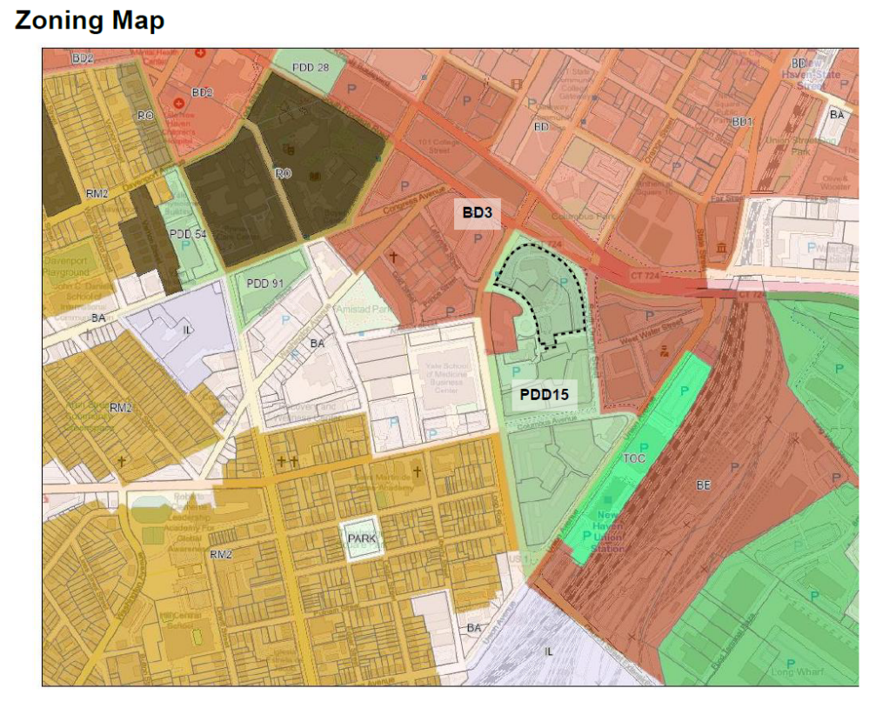

SECTION VII: PREDEVELOPMENT TEAM
The Towers procured a predevelopment team to assist in the initial exploration of Tower Three. This dynamic team brings together the right mix of talent across various sectors.
Role | Firm | Contact
Engineer | Langan | Katy Gagnon
Environmental Consultant | Fuss O’ Niell | Kathleen Payne
Master Planning | Newman Architects | Dov Feinmesser
 | Yale Urban Design Workshop | Alan Platuss
Land Use Attorney | Brenner, Saltzman & Wallman LLP | Carolyn Kone
Project Counsel | McCarter & English LLP | Rolan Young
Project Manager | HousingSmarts | Elizabeth Torres
Real Estate Development Advisors | HRA Advisors | Thomas Jansen
The team members identified above are available for further stages of the development but there is no long-term obligation to use them.

SECTION VIII: PROPOSAL SUBMISSION REQUIREMENTS
Respondents must submit the following for the Qualifications to be considered complete.
Proposals received without all the required information may be rejected. Proposals must
including the following information exhibits and schedules:
A. General Information/Overall Firm Capabilities
1. Letter of Interest, including contact name and telephone number (Cover letter).
2. Confirm organizational ownership information indicating type of organization: corporation, partnership, joint venture, sole proprietorship, or other. Names of shareholders, partners, principals and any other persons exercising control over the Respondent.
3. Provide history and description of firm.
B. Previous Experience/References
1. Describe current specific experience in real estate development experience in the State of Connecticut, including units subject to compliance with the LIHTC requirements of Connecticut Housing Finance Authority. Respondents should demonstrate specific experience managing projects financed with LIHTC and of a similar size.
2. Provide a list of properties currently under development and identify the following for each property: name of property, address, number of units, type of property (e.g., multifamily, senior), financing program(s) expected to be used.
3. Provide information about Respondent’s past clients for whom the Respondent provided the same or similar services. Respondents must provide at least two (2) references.
4. Share three project examples that were developed in partnership with a housing authority, municipality or nonprofit and compensation structure.
C. Proposed Staffing and Sub-Contractor Responsibilities and Qualifications
1. Include bios/resumes and description of key staff and relevant experience.
2. Offer scope of discipline Respondent can provide in-house versus outsource.
D. Equity and Inclusion
1. Present firm’s statement on equity and inclusion.

SECTION XI. METHODOLOGY FOR EVALUATING QUALIFICATIONS
The Towers will review Qualifications submissions in accordance with the Evaluation Criteria listed below. The Towers reserves the right to reject any or all Qualifications or to waive any informalities or irregularities when, in the opinion of The Towers, such rejections or waivers shall be to its interest or advantage.
At The Towers option, Respondents may be asked to participate in an interview process to discuss how they will specifically apply their Qualifications and experience to the development of the Development Property.
- RFQ EVALUATION CRITERIA
The Towers will use the criteria such as those listed below in evaluating Qualifications.
No. | Criteria and Description
1 | Development Partner/Team Capacity.  This score addresses the capacity and caliber of the Development Partner, its team and the primary staff assigned to this project.  Development Partners will be evaluated on success in completion of development projects. Weight will be given to completed projects that are similar in scale, affordability, and in anticipated funding sources (the City of New Haven and State of Connecticut) to the project contemplated in this RFQ.  A minimum of 5 relevant urban planning projects should be shared including project name, client, year completed.
2 | Local Knowledge.  This score addresses the Developer’s experience working in the City of New Haven and understanding of the City’s EEO requirements, tax policy, and local processes.
3 | Community Impact.  This score addresses the Developer’s track record of generating positive community impact from its projects, including resident outcomes, community empowerment, and engagement with the local community.
4 | Equal Opportunity/Culturally Aware Development.  Points given to developers from underrepresented communities in real estate development, including registered M/WBEs, and nonprofit entities run by underrepresented races and genders.

- SPECIAL CONDITIONS
Best Available Data. All information contained in this RFQ is the best data available to The Towers at the time the RFQ was prepared. The information given in the RFQ is not intended as representations having binding legal effect. The information is furnished for the convenience of respondents, and The Towers assumes no liability for any errors or omissions.
Communication with Respect to the RFQ. To maintain the integrity of the procurement process, all communication regarding this RFQ must be presented to The Towers contact as noted in Section I. Respondents are instructed not to communicate with The Towers staff and/or The Towers Board members about this procurement until the procurement process has been completed or otherwise terminated by the Towers. Evidence of any such communication by any Respondent may be cause for disqualification.
Equal Opportunity. The Towers is an equal opportunity employer committed to affirmatively furthering fair housing. The Towers encourages small businesses and businesses underrepresented in real estate development to apply.
Revocation Right. The Towers reserves the right to reject any proposal submitted in response to this RFQ, for any reason, in the best interest of The Towers. The Towers reserves the right to modify or rescind the RFQ for any reason at any time. The Towers will not compensate Respondents for the work and time incurred in responding to the RFQ, and any and all costs and expenses of the Respondent shall be the sole responsibility of the Respondent.
Confidentiality. The firm agrees that any information received during the term of Agreement which concerns the financial or other affairs of The Towers will be treated by the firm in full confidence and will not be revealed to any other persons, firms or organizations except (i) as may be authorized by The Towers in advance; (ii) as may be necessary for the firm to fulfill its obligations under its Agreement; or (iii) except as may be otherwise required by law or any court proceeding.
Agreement. This RFQ and any relationship between a successful Respondent are subject to the successful negotiation of an agreement between the Respondent and The Towers. Notwithstanding anything to the contrary contained herein, The Towers shall have the right, in its sole and absolute discretion, to accept or reject any such agreement as The Towers determines to be in the best interests of The Towers.

